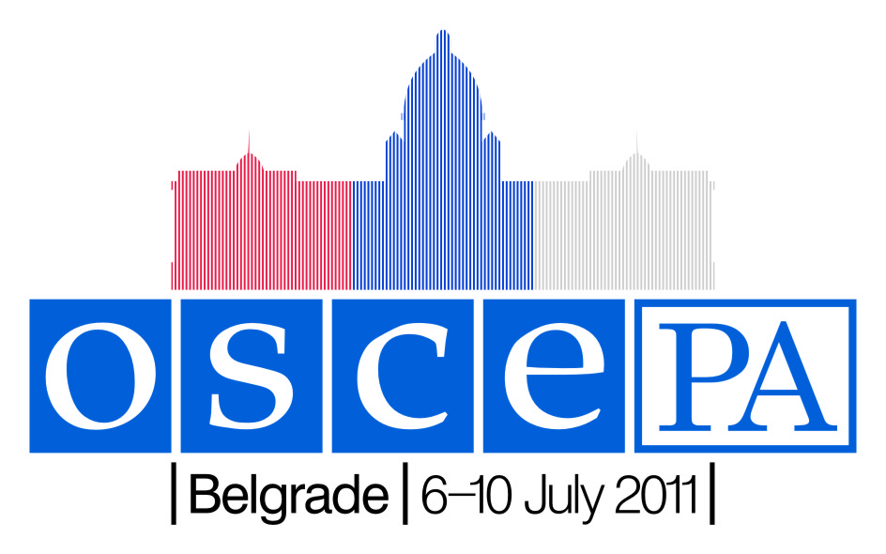

Appendix B

REGISTRATION FORM
20th Annual Session OSCE Parliamentary Assembly, Belgrade, 6 – 10 July 2011

Each delegation is kindly asked to complete this form and return it no later than 1st June 2011 to:
Odile Lelarge  OSCE Parliamentary Assembly  International Secretariat  Tel : (+45) 33 37 80 40  Fax : (+45) 33 37 80 30  E-Mail: odile@oscepa.dk | Veljko Rackovic  Serbian Parliament  Tel.: (+381) 11 3026 364  Fax: (+381) 11 3227  E-Mail: v.rackovic@parlament.rs

Country or organization :
Contact Person :
Telephone :
Fax :
E-mail :
Hotel in Belgrade:

Delegation registration
Last name, First name, Mr./ Ms. | Title(s)  Speaker of the Parliament, Vice-President, Head / Member of delegation, Secretary of delegation, etc… | Standing Committee  (x) | Committee  (1-2-3) | Accompanied  by : | Arrival  date | Time | Flight  N° | Depart.  date | Time | Flight  N°

Delegation registration
Last name, First name, Mr./ Ms. | Title(s)  Speaker of the Parliament, Vice-President, Head / Member of delegation, Secretary of delegation, etc… | Standing Committee  (x) | Committee  (1-2-3) | Accompanied  by : | Arrival  date | Time | Flight  N° | Depart.  date | Time | Flight  N°

Date : _____________________________________ Signature : __________________________________

