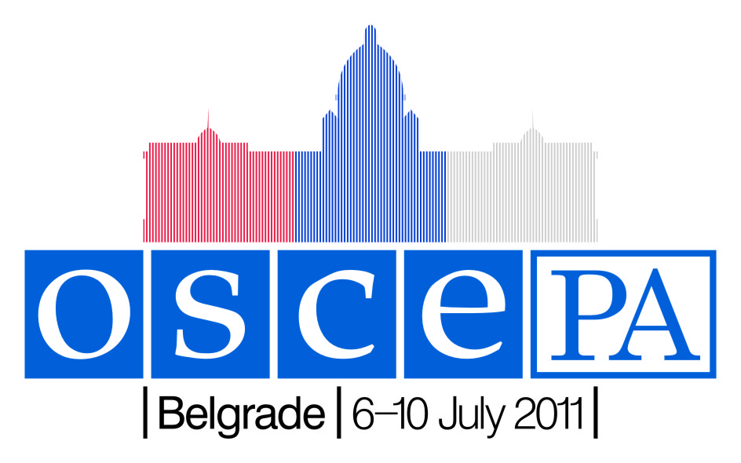
OSCE Parliamentary Assembly
Appendix A
Annual Session, Belgrade 6-10 July 2011
HOTEL RESERVATION FORM
Please complete one form per guest and return by 27 May 2011 to Ms. Maja Drašković, Protocol of the National Assembly; majadra@parlament.rs or fax +381 11 3227 299
with copy to Ms. Odile Lelarge at the OSCE PA International Secretariat; odile@oscepa.dk or fax +45 33 37 80 30

Hotel | Room type | Price in Serbian Dinar (RSD) | Equivalent in € based on exchange rate of 1/02/2011 **
Hotel | Room type | incl. breakfast and VAT.
*Hotel Hyatt Regency | King/twin single room | 19226 | € 184 | □
*Hotel Hyatt Regency | King/twin double room | 22080 | € 212 | □
*Hotel Hyatt Regency | Deluxe king single room | 22613 | € 217 | □
*Hotel Hyatt Regency | Deluxe king double room | 25467 | € 244 | □
*Hotel Hyatt Regency | Regency king/twin single room | 26000 | € 249 | □
*Hotel Hyatt Regency | Regency king/twin double room | 28853 | € 276 | □
*Hotel Hyatt Regency | Regency club deluxe single | 28258 | € 271 | □
*Hotel Hyatt Regency | Regency club deluxe double | 31112 | € 298 | □
*Continental Hotel | Standard single room | 7318 | € 72 | □
*Continental Hotel | Standard double room | 8364 | € 82 | □
*Continental Hotel | Deluxe single room | 9409 | € 92 | □
*Continental Hotel | Deluxe double room | 10455 | € 102 | □
*Hotel In | Standard single room | 11079 | € 107 | □
*Hotel In | Standard double room | 12114 | € 117 | □
Holiday Inn | Standard single room | 12023 | € 115 | □
Holiday Inn | Standard double room | 13591 | € 130 | □
Holiday Inn | Executive single room | 15159 | € 145 | □
Holiday Inn | Executive double room | 16727 | € 160 | □
*Hotel Moskva | Standard single room | 9800 | € 94 | □
*Hotel Moskva | King single room | 12420 | € 119 | □
*Hotel Moskva | King double room | 13800 | € 132 | □
*Hotel Moskva | Duplex king single room | 14490 | € 140 | □
*Hotel Moskva | Duplex king double room | 16100 | € 154 | □

Smoking Room: Yes □ No □
*Suites are available on request in the Hyatt Regency, the Continental Hotel, the In Hotel, and the Hotel Moskva
** For information only
Rooms are subject to availability and cannot be guaranteed after 27 May 2011
Delegation of:
Surname: |  | First name: |  | Mr /Ms:
Full title:
Accompanied by
Postal address:
Zip code: |  | City:
Country: |  | Telephone:
E-mail: |  |  | Telefax:
Appendix A

Date of arrival: | / / | Flight number: |  | Time:
Date of departure: | / / | Flight number: |  | Time:

Payment

- The hotels require your credit card details in order to guarantee your booking
- Participants will pay for the entire duration of their stay directly to the hotel

Name of the credit card holder:
Credit card number for guarantee: |  |  |  | Exp.date: | /
Signature of the credit card holder:

Cancellation policy for all hotels

- Cancellations must be sent in writing to the contact information at the top of this form
- Cancellations after 7 June will be charged to the above credit card according to below terms:
      - 7-21 June: one night charged
      - 22-28 June: two nights charged
      - From 29 June: whole stay charged

For further information on amenities in each hotel including smoking policy, please consult the individual hotel websites:

Hyatt Regency: www.belgrade.regency.hyatt.com
Continental Hotel Belgrade: www.continentalhotelbeograd.com/home.40.html
IN Hotel: www.inhotel-belgrade.rs
Holiday inn Belgrade: www.holidayinn.com/hotels/us/en/belgrade/begbg/hoteldetail
Hotel Moskva: www.hotelmoskva.rs/en/

