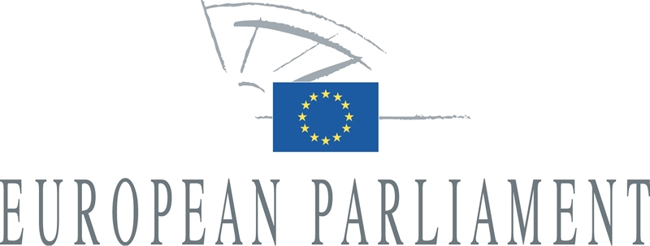 | 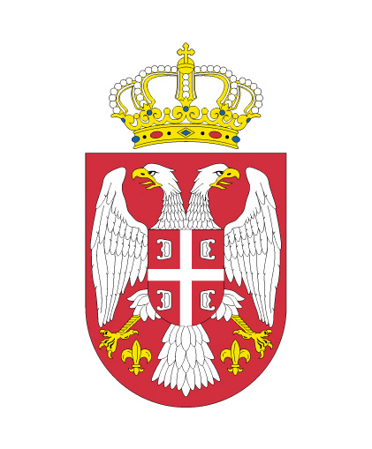
Delegation for relations with Albania, Bosnia and Herzegovina, Serbia, Montenegro and Kosovo | National Assembly  Republic of Serbia  Committee on European Integration

6th Inter-parliamentary Meeting
27-28 September 2012, Belgrade

JOINT STATEMENT
by the Chairpersons of the Delegations

At the conclusion of the 6th European Parliament – National Assembly of the Republic
of Serbia Inter-parliamentary Meeting, held in Belgrade on 27-28 September 2012, the two delegations:

1. Welcomed the fact that a new government has been formed after the general elections of
6 May 2012 and the new Government's commitment is to continue to deliver on the European integration agenda;

2. Noted positively the conclusions of the OSCE/ODIHR final report on the Serbian parliamentary and early presidential elections stating that these polls were characterised by
a respect of fundamental rights and freedom; invited the new Government to take up the recommendations contained in this report in order to further enhance the transparency of the election process;

3. Encouraged the new Government, after limited progress on the EU integration agenda since March 2012 when Serbia received the EU candidate status, to adopt and fully implement key EU reforms related especially to the judiciary, anti-corruption policy, media freedom, equal protection of all minorities, protection of environment, sustainable management of natural resources and biodiversity, structural economic reforms and the improvement of the business environment; in that regard; called on the Serbian government to implement as soon as possible the Resolution of the European Parliament of 29 March 2012;

4. Recommended to local authorities to implement the legally guaranteed competencies of national councils; underlined that the implementation of minority rights by the executive is as important as the legislative act itself;

5. Highlighted the importance of finalising the national Anti-corruption Strategy and Action Plan with clear indicators, timelines, responsible actors and required resources necessary for the implementation of the Strategy; encouraged the new Government to demonstrate strong leadership in the fight against corruption; welcomed the work carried out by the Anti-Corruption Council and Anti-Corruption Agency; underlined that the fight against crime and corruption should not be misused for a fight against political opponents, and penal legislation should not be the instrument of deterring people;

6. Called on the state to implement the Media Strategy, with particular focus on transparency of ownership and the financing of the media sector and create a climate conductive to media freedom and the safety of journalists;

7. Expressed concern about repeated allegations of misuse of the penal provisions by prosecutors on economic crime offences accompanied by freezes of company and private assets; called on the authorities to swiftly proceed with a revision of the Criminal Code to put an end to the bringing of charges of abuse of public office in private (and with majority private ownership) enterprises and to end the pending criminal proceedings, especially based on Article 359 of the Criminal Code; to ensure open access to all relevant privatisation documentation;

8. Expressed satisfaction about the overall progress in the reform of the public administration and encouraged the new Government to fully implement the legal framework on the public administration reform; took note of the amendments to the Law on Government and stressed the importance of ensuring that independent regulatory agencies should have adequate financial and administrative capacity, so they can exercise their statutory powers without improper political or governmental influence;

9. Were aware of concerns regarding the post-election legislative initiatives leading to personal changes in the state institutions and in the civil service, e.g. through adoption of the new law on the National Bank or through the provisions of the newly adopted Law on Ministries, which enables a minister to propose a dismissal of any appointed civil servant;

10. Expect the Serbian Government together with the government of the Autonomous Province of Vojvodina to overcome the current situation in order to find a solution which respects the competences of the Province, rule of law and subsidiarity; reminded the parties that according to the Constitution the law on financing of the Autonomous Province should have been adopted by the end of 2008; thus encouraged the Government to draft and submit to the Parliament the law on the functioning of the autonomy without any further delay, as this is indispensable to the functioning of democracy and the rule of law in Serbia;

11. Highlighted the importance that Serbia continues its active and constructive role in the region, particularly with regard to efforts to strengthen and streamline BiH state-level institutions; stressed that good neighbourly relations, respect for the rights of the minorities and regional cooperation are essential for the enlargement process; insisted on the need to implement the minorities legislation, including the provision of relevant textbooks for all minorities; expressed commitment to work towards resolving problems in local communities, when they arise;

12. Underlined the need for an active government involvement, in cooperation with civil society organizations, in protection of minorities' rights; in this respect, called on the Serbian authorities to secure adequate funding of Minority Councils and to ensure the freedom of expression of all minorities regardless of their cultural, ethnic, religious background or sexual orientation;

13. Expressed the expectation that, in the event that the Belgrade Pride takes place on
6 October 2012, the safety of participants will be guaranteed, showing Serbia's commitment to the freedom of assembly and the principle of non-discrimination;

14. Welcomed the reaffirmation by the new Serbian President and Prime Minister to continue the dialogue between Belgrade and Pristina and to implement all agreements reached with Pristina so far and called for swift implementation of this declaration; noted positively the new Serbian Government's instruction of early September on the country's participation at regional summits, enabling inclusive regional cooperation;

15. Welcomed the Council's decision to grant Serbia candidate status on 1 March 2012; Reiterated that a visible and sustainable normalization of relations between Belgrade and Pristina, in accordance with the criteria defined in the stabilization and association process, remains a key requirement for the next step of Serbia's EU integration process; considered that the Council should set a date for the opening of the accession negotiations as soon as possible in accordance with the conclusions of the European Council;

16. Expressed a concern about the deteriorating economic situation in Serbia, which had been adversely affected by the global economic and financial crisis; stressed the need to address the country's economic weaknesses especially the high budget deficit, the slow progress of structural reforms and transparent completion of the privatisation process as well as the high unemployment and develop sound economic and social policies to support economic recovery and social cohesion in the future;

17. Invited the remaining EU Member State - Lithuania - to complete the ratification of the Stabilisation and Association Agreement (SAA) between the EU and Serbia in order to further intensify the bilateral relations; expressed the joint commitment and interest to upgrade the inter-parliamentary dialogue to a Stabilisation and Association Parliamentary Committee once the SAA enters into force;

18. Called on the European Commission and Member States to maintain the level of IPA funding for the period 2014-2020 on the current level.

European Parliament resolution of 29 March 2012 on the European integration process of Serbia (2011/2886(RSP)): http://www.europarl.europa.eu/sides/getDoc.do?type=TA&language=EN&reference=P7-TA-2012-114

