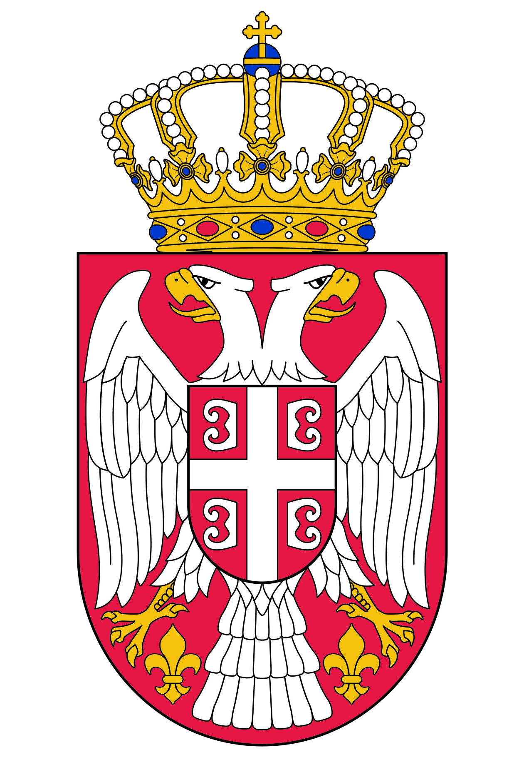
NATIONAL ASSEMBLY OF THE
REPUBLIC OF SERBIA

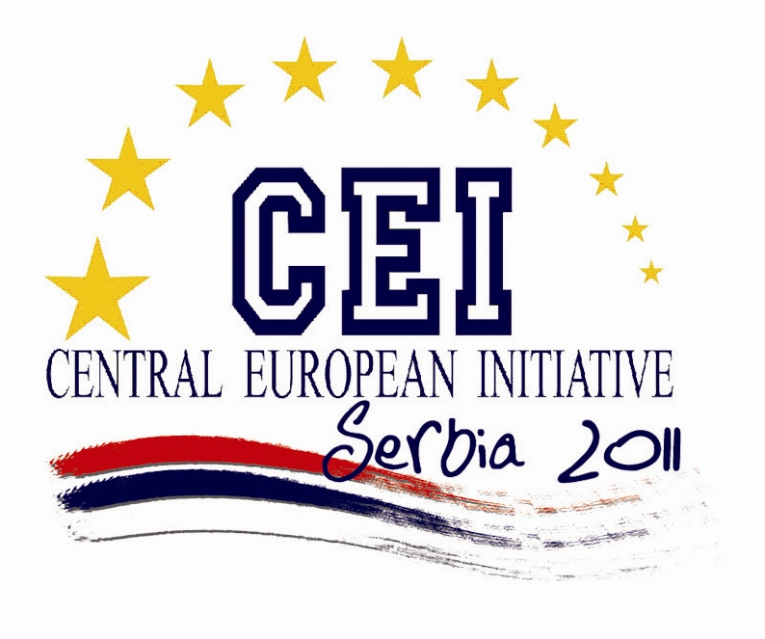

PARLIAMENTARY ASSEMBLY OF THE CENTRAL EUROPEAN INITIATIVE PARLIAMENTARY DIMENSION
Belgrade, 9 - 11 November 2011

FINAL DECLARATION

Being aware of changes in geo-political and economic structure of the world, and of the need to adapt CEI to the new world developments, and in view of successful realisation of the Organisation's goals,

Having in mind the economic difficulties caused by the new wave of the crises faced by Europe and the rest of the world, but also the economic advantages that the continuation of the European integration process and the market growth will bring to everyone,

Strongly emphasizing the importance of the European perspective offered to the Western Balkan region, which contributes to improving, preserving and promoting political stability, the respect of human rights, support of expression and protection of minority rights, as well as cooperation between them, aiming to enhance economic development of the region,

Emphasizing the importance of the Eastern Partnership and its further development,

Recognising the special role that, owing to their specific geo-political position, the Western Balkan countries can play in the European fight against organised crime and trafficking in human beings

Parliamentary Assembly of the Central European Initiative Parliamentary Dimension

Calls for resolute continuation of European integration process and full integration of the EU candidate and potential candidate countries of the CEI and for further development of cooperation between the Eastern Partnership and European Union Member States aiming at Europe as a continent of peace, stability and economic prosperity as a goal,

Expresses concern about the new wave of the world economic crises faced by Europe and about its potential negative impact on the EU enlargement process, and on strengthening the cooperation between EU and Eastern Partnership Member States,

Welcomes the continuation of systemic reforms and the progress achieved by the Southeast European countries in reaching European democratic standards and market economy development,

Supports European Commission's assessments of the progress by the EU enlargement countries, and the EC recommendations regarding the progress of these countries in the European integration and EU accession processes when all conditions are met,

Calls upon to the Council of EU/European Council to support the recommendations of the European Commission and the decision of the Council of the Union regarding the EU candidate and potential candidate countries,

Underlines a significant progress achieved in the cooperation between the Western Balkan countries on political, economic and cultural issues and calls for further development and improvement of relations in the region,

Particularly recognises, in the period of new global and economic developments and financial challenges, the need for further strengthening of CEI work, in order for this organisation to successfully continue achieving its goals,

Calls for further development of cooperation between the Member States with a view to ensuring higher quality of work and more successful realisation of interests of the Member States in the context of new challenges imposed by the geo-political reality,

Appeals for strengthening cooperation and better coordination between the Parliamentary, Governmental and Business Dimensions of the Central European Initiative, with a view to adapt the Organisation to modern challenges and to enable it work more successfully on achieving organisational goals set up at its establishment,

Indicates the importance of strengthening cooperation between CEI and other regional initiatives and calls for further improvement of the cooperation also at the parliamentary level and for taking concrete steps regarding this issue, including the Danube Strategy and the process towards an Adriatic and Ionian macro-region,

Welcomes the strengthening of the CEI dialogue with civil society, as auspicated by the CEI parliamentary Assembly last November 2010 and also by the CEI Ministers of Foreign Affairs in June 2011, and encourages the establishment of a CEI Network of Civil Society Organisations as soon as possible to further proceed along this path,

Takes note of the proposal of the CEI Business Forum, held in Belgrade on 4 November 2011, wishing that the CEI business dimension might be revitalized by providing a direct voice to the business communities of the CEI member countries as a whole,

Welcomes the Trieste Declaration adopted by the CEI Ministerial Meeting on Science and Technology, held last October in Trieste, on strengthening the cooperation in these fields as well as in the field of renewable and ecofriendly sustainable energy,

Emphasises the importance of further intensifying the cooperation of CEI with the European Commission, as the European Union, through concrete cooperation projects and connecting at regional level,

Acknowledges the need and indicates the importance of granting the observer status to the Central European Initiative in the United Nations General Assembly,

Recalls the importance of the CEI-EBRD 20-years cooperation, and particularly stresses the relevance of technical assistance projects provided through the CEI Fund at the EBRD, aimed to assist the CEI Member States in their economic and social transformation process,

Expresses gratitude to Italy for the important role it has played in CEI activities all these years, and for the significant contribution it has made to the achievement of the Organisation's goals,

Expresses support to Ukraine as the following CEI presiding country for the year of 2012, after the Serbian mandate ends, completely convinced that through its activities it would contribute to strengthening the role of CEI, enhancement of cooperation within the region, and its European integration.

